

Research on Chest X-rays to deduct various respiratory infections

MSc Project Research Proposal

Kutala Mohan Prasad

Supervised by

Dr. Sabah Mohammed, PhD, ISP, IEEE Senior Member, PEng (Full Professor)

Department of Computer Science

Lakehead University

Ontario, CANADA

Reference: COMP5800_Fall2021_1154915

Date: 06/12/2021

**Introduction** 2

**Background and Context** 3

**Analyzing the image** 4

**Problem Statement** 4

**Research Questions** 5

**Relevance and Importance of the Research** 6

**Severity of the Disease** 7

**Literature review** 7

**Research design and methods** 8

**Research design** 8

**Data and Datasets** 9

**Methods and Sources** 10

**Implications and contributions to knowledge** 12

**References** 13

**Research schedule** 16

# **Introduction**

Since 2020, we see world suffering from dangerous virus called COVID-19 [1]. Once the patient effected by this virus it will act as a slow poison to him to die main reason for this is respiratory problem, this virus will infect all tissues inside the lungs so, slowly it will be very hard to the human to take breath and finally he will die. In mean time every doctor will do chest x-ray scan to measure the severity of the disease and infection inside the lungs. Usually medical guys will know the status of the disease very easily by seeing the reports and X-ray images but the public who don’t have idea on medical terms they will not understand the infected area and infected severity.

After having above idea in my mind I just want to do research on available X-Rays to know the severity of the disease and level of infection inside the body so that public can alert and have a chance to consult or ask doctor for remedy for the damage and doctors can easily identify and give proper medication to the patient. I thought to explore X-ray images as doctors frequently use X-rays and CT scans to diagnose pneumonia, lung inflammation, abscesses, and enlarged lymph nodes. Since COVID-19 attacks the epithelial cells that line our respiratory tract, we can use X-rays to analyse the health of a patient’s lungs. Given that nearly all hospitals have X-ray imaging machines, it could be possible to use X-rays to test for COVID-19 without the dedicated test kits [2].

## **Background and Context**

We have so many research areas to do on noise environments for example audio, video and image analysis etc., but these are common in now a days to do on these type of topics. So, I selected ***Health care Department*** to do my research. My goal is simply to inspire the world and open eyes to show how studying computer deep learning, AI, ML and then applying that knowledge to the medical field can make a big impact on the world. As per my research I see only few papers were published on health care when compare to other research areas. Most of the recent papers were published on ***EHR (Electronic health records)*** it might be diabetes, heart diseases, Allergy information, Emergency department visits, Hospital discharge summaries and reports, Drug and Pharmacy Service Information , Neurophysiology reports, Patient consultation reports etc., As per my knowledge we had few papers only worked on respiratory reports [3].

EHR Data can come from many different sources in today's world. Data such as:

* Heart rate monitors
* X-Rays and other radiology scans
* Fitness trackers
* Other diagnostic tests

All this helps to provide a 360-degree view of a patient's health. Ensuring that this data is collected in an electronic health record is very valuable to the patient and their caregivers. This data becomes even more critical when you can get a longitudinal view of a patient's data and collect it in a way that allows healthcare professionals and data scientists to make meaningful and accurate predictions [4]. To make this data even more impactful and create better insights and predictions, we need to be able to aggregate the data of many to help address some of the most significant opportunities in healthcare [3].

## **Analyzing the image**

X-ray images as a doctors frequently use X-rays and CT scans to diagnose pneumonia, lung inflammation, abscesses, and enlarged lymph nodes. Since COVID-19 attacks the epithelial cells that line our respiratory tract, we can use X-rays to analyse the health of a patient’s lungs [5]. To analyse the X-ray images we should know the different parts of the X-rays for example if the lungs filled with total air then what it will show in X-ray, what if we have bone fractures inside the lungs. What will be the identification of other tissues, normally Air appears black, fat appears gray, soft tissues and water appear as lighter shades of gray, and bone and metal appear white. The denser the tissue, the whiter it will appear on x-ray. Denser tissues appear radiopaque, bright on the film; less dense tissues appear radiolucent, dark on the film.

Chest x-ray review is a key competency for medical students, junior doctors and other allied health professionals. Using A, B, C, D, E is a helpful and systematic method for chest x-ray review [5]:

A: airways

B: breathing (the lungs and pleural spaces)

C: circulation (cardiomediastinal contour)

D: disability (bones - especially fractures)

E: everything else, e.g. pneumoperitoneum

## **Problem Statement**

A drawback is that X-ray analysis requires a radiology expert and takes significant time which is precious when people are sick around the world. Therefore developing an automated analysis system is required to save medical professionals valuable time.

If we have Image noise for our dataset what we have to do? What is the percentage of noise on the image? How we have to reduce that noise level on the image?

The common types of noise that are present in x-ray images are Poisson noise, salt and pepper noise, and speckle noise. The salt and pepper is seen in the image as white and black pixels respectively. Poison noise is as a result of uneven distribution of x-rays over the receptor surface. Speckle noise on the other hand occurs as a granular appearance in an image which is produced as a result of random fluctuations in the return signal from an object which is not found to be bigger than a single image processing element. Within a specific area, speckle noise is able to increase the mean grey level.

An image pre-processing step can improve the accuracy of machine learning models. Pre-processed images can help a basic model achieve high accuracy when compared to a more complex model trained on images that were not pre-processed. For Python, the Open-CV and PIL packages allow you to apply several digital filters. Applying a digital filter involves taking the convolution of an image with a kernel (a small matrix). A kernel is an n x n square matrix were n is an odd number. The kernel depends on the digital filter [6].

We have different types of techniques to remove the noise inside the image such as

* Mean filter [7]
* Gaussian Filter [8]
* Median Filter (Highly recommended filter to remove Salt and pepper noise) [9]
* Other Filters [10]

## **Research Questions**

**RQ1: Removing or adding noisy data** as a radiographer, your goal from day to day, from patient to patient, is to complete an imaging exam that provides sufficient information for an accurate clinical diagnosis. The patient’s anatomy has created variations in the X-ray intensity that the imaging system uses to create the image. But overlaying this image “signal” is the inherent statistical “noise” associated with the X-ray production process. As you will see, there are two main challenges. One is that the X-ray process is governed by fundamental laws of nature that we cannot alter and whose characteristics introduce unavoidable “noise”. The second is that the multiple processes in the X-ray image capture process also generate noise, but they are amenable to optimization through careful detector design. In an chest X-ray test where only a small amount of radiation has been used to create the image (low exposure), the distracting visual appearance of the statistical noise (sometimes known as “salt and pepper” noise) relative to the size of the signal variations generated by the patient’s anatomy, can reduce the visibility of subtle, clinically important features. This can lower the radiologist’s diagnostic confidence.

**RQ2: Detecting COVID-19 severity using chest X-rays** novel coronavirus disease (COVID-19) is the most challenging problem for the world. The disease is caused by severe acute respiratory syndrome coronavirus-2 (SARS-COV-2), leading to high morbidity and mortality worldwide. The COVID-19 test is typically done on respiratory samples obtained by a nasopharyngeal swab. However, a nasal swab or sputum sample may also be used. Results are generally available within hours based on the test type. Chest X-rays scans may be helpful to diagnose COVID-19 in individuals with a high clinical suspicion of infection. Radiology experts will have possibility to detect the COVID-19 virus using chest X-rays. For this detecting we have to analyse the negative chest X-rays along with normal or positive X-rays to identify whether the two lungs are effected or not.

People with these symptoms may have COVID-19:

* Fever or chills
* Cough
* Shortness of breath or difficulty breathing
* Fatigue
* Muscle or body aches
* Headache
* New loss of taste or smell
* Sore throat
* Congestion or runny nose
* Nausea or vomiting
* Diarrhea

**RQ3: Detecting Pneumonia Severity using chest X-rays** Pneumonia is an infection that causes inflammation in one or both of the lungs. It can be caused by a virus, bacteria, fungi or other germs. The infection is usually acquired when a person breathes in air carrying germs. Your doctor may conduct a physical exam and use chest x-ray, chest CT, chest ultrasound, or needle biopsy of the lung to help diagnose your condition. Your doctor may further evaluate your condition and lung function using thoracentesis, chest tube placement or image-guided abscess drainage.Most at risk for developing pneumonia are young children or people over the age of 65.An x-ray exam will allow your doctor to see your lungs, heart and blood vessels to help determine if you have pneumonia. When interpreting the x-ray, the radiologist will look for white spots in the lungs (called infiltrates) that identify an infection. This exam will also help determine if you have any complications related to pneumonia such as abscesses or pleural effusions (fluid surrounding the lungs). Pneumonia can sometimes lead to serious complications, such as respiratory system failure, spread of infections, fluid surrounding the lungs, abscesses or uncontrolled inflammation throughout the body (sepsis). The condition can also be fatal, so it is important to seek immediate medical attention if you are experiencing these symptoms.

Patients with pneumonia could have the following symptoms:

* cough that produces phlegm or sometimes blood
* fever
* shortness of breath or difficulty breathing
* chills or shaking
* fatigue
* sweating
* chest or muscle pain

## **Relevance and Importance of the Research**

As per my research I see the radiologists rated pulmonary parenchymal involvement using a semi quantitative severity score, subdividing each lung into three zones upper zone (from the lung apex to the aortic arch profile), middle zone (from the aortic arch profile to the lower margin of the left pulmonary hilum), and lower zone (from the lower margin of the left pulmonary hilum to the diaphragm). For each zone, a score on a scale from zero to three in 1-point increments was assigned: 0, normal lung parenchyma; 1, interstitial involvement only; 2, presence of radiopacity for less than 50% of the visible lung parenchyma; 3, presence of radiopacity for 50% or more than 50% of the visible lung parenchyma [11].

Based on the Scale inputs given by the radiologists we have to give random images or X-rays to severity function to measure and show the severity rate of the X-ray when compare to the normal human X-ray before effecting that infection [12].

## **Severity of the Disease**

The model to check the severity of the disease for example negative and positive case x-rays if we take based on the disease the model will identify if its positive case it will define the severity of that disease inside other model. Here severity can be taken from RALO (Radiographic Assessment of Lung Opacity) dataset in which Radiological scoring was performed by three blinded experts: two chest radiologists (each with at least 20 years of experience) and a radiology resident. They staged disease severity using a score system, based on two types of scores (parameters): extent of lung involvement and degree of opacity [13].

**Extent of lung**:

0 = no involvement

1 = <25% involvement

2 = 25%-50% involvement

3 = 50%-75% involvement

4 = >75% involvement.

**Degree of Opacity**:

0 = no opacity

1 = ground glass opacity

2 = consolidation

3 = mix of consolidation and ground glass opacity (>50% consolidation)

4 = white-out

The total opacity score ranged from 0 to 8 (right lung and left lung together).

# **Literature review**

Shivani Guptaa,­, Atul Guptab they performed a systematic review on noise identification and handling studies published on various conferences and journals between January 1993 to July 2018. They identified 79 primary studies are of noise identification and noise handling techniques. After investigating these studies, they found that among the noise identification schemes, the accuracy of identification of noisy instances by using ensemble-based techniques are better than other techniques. But regarding efficiency, usually single based techniques method is better it is more suitable for noisy data sets [14].

Brett K talks about the EHR data how and where the medical records were collecting and how denoising autoencoders perform dimentionality reduction enabling visualization and clustering for the discovery of the new subtypes of the disease [15]. VisionPro Deep Learning is used to classify these Chest X-rays from the COVID dataset. The results are compared with the results of COVID-Net and various other state-of-the-art Deep Learning models from the open-source community. Segmenting the lungs in the first step, and then doing the classification step on the segmented lungs only, instead of using the entire image [16]. Apart from that deep learning based approach for the identification and localization of pneumonia in Chest X-rays (CXRs) images. Mask RCNN based model gives more accurate pixel wise semantic segmentation than faster RCNN for pneumonia prone regions in the lungs were discussed by SachinKumar and his team [17].

Madhava raja and his team develop a Deep-Learning System (DLS) to diagnose the lung abnormality using chest X-ray (radiograph) images.

(i) Conventional chest radiographs

(ii) Chest radiograph treated with a threshold filter. The initial experimental evaluation is carried out using the traditional DLS, such as AlexNet, VGG16, VGG19 and ResNet50 with a SoftMax classifier. The results confirmed that, VGG19 provides better classification accuracy (86.97%) compared to other methods [18]. To develop the system to auto detect the covid-19 positive cases such that they selected few different methods in each level and tested the dataset against the model. Convolutional Neural Network with a classification accuracy of 83.02% and a superior AUC of 0.907, which would mean a better ability to detect the COVID19 using this method.100% accuracy on the validation set using the feed-forward neural network, and this is using as inputs the flattened image and the texture features. Feature-based feed forward NN with an 84.02% classification accuracy and an AUC of 0.850 [19].

# **Research design and methods**

## **Research design**

Utilization of Machine Learning is common in all the fields including health care but most hospitals are not currently deploying machine learning solutions. One reason for this is that health care professionals often lack the machine learning expertise that is necessary to build a successful model. In order to make machine learning techniques easier to apply and to reduce the demand for human experts. Most of the models wants a human interaction in each stage to add, deploy and run the model. Don’t we run the machine learning models without human interaction in such a way that a model should take input from the user and run on its own way to give output? Yes, we have automated machine learning (AutoML) has emerged as a growing field that seeks to automatically select, compose, and parametrize machine learning models, so as to achieve optimal performance on a given task and/or dataset [20].

The Auto Machine Learning is technique that machine will run the code by taking the input from user. As shown in figure 1, pipeline it will take set of filtered chest images as input and it will run couple of Machine Learning models to detect and report the severity of the disease. There are several key challenges to applying machine learning in the healthcare space that make it very difficult to deploy AutoML solutions [20]. An important challenge in any machine learning problem is assembling a high-quality, representative, and diverse dataset. Ideally, the machine learning model would be trained with data that exactly matches the format and quality of data that would be used at a later point.

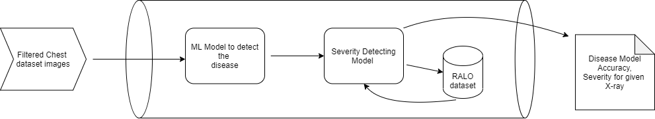Using Machine learning model in health care department is not popular now a days because of not having ML experts in health care department and the models are not giving the accurate performance and the main reason for this is lack of data. If the person wants to run the ML model he should have idea on what we are running and how we have to run the model. But if we have a model or Auto ML technique it will be easy to run and get the results.

Figure 1: Auto ML Pipeline

## **Data and Datasets**

A team of researchers from Qatar University, Doha, Qatar, and the University of Dhaka, Bangladesh along with their collaborators from Pakistan and Malaysia in collaboration with medical doctors have created a database of chest X-ray images for COVID-19 positive cases along with Normal and Viral Pneumonia images. This COVID-19, normal and other lung infection dataset is released in stages. In the first release they have released 219 COVID-19, 1341 normal and 1345 viral pneumonia chest X-ray (CXR) images. In the first update, they have increased the COVID-19 class to 1200 CXR images. In the 2nd update, they have increased the database to **3616** COVID-19 positive cases along with **10,192** Normal and **1345** Viral Pneumonia images [21] [23].

A dataset of **2373** Chest X-ray (CXR) images from Stony Brook Medicine. Each CXR has been scored by two radiologists. There are multiple CXRs per patient and temporal information is included [13].

A dataset of 3,875 images for training of pneumonia with 1341 normal chest x-rays. Testing with 390 images and 234 normal images for it. They have used 9 pneumonia images and 8 normal images for validation of model [22].

Severity can be taken from RALO (Radiographic Assessment of Lung Opacity) dataset in which Radiological scoring was performed by three blinded experts [13].

## **Methods and Sources**

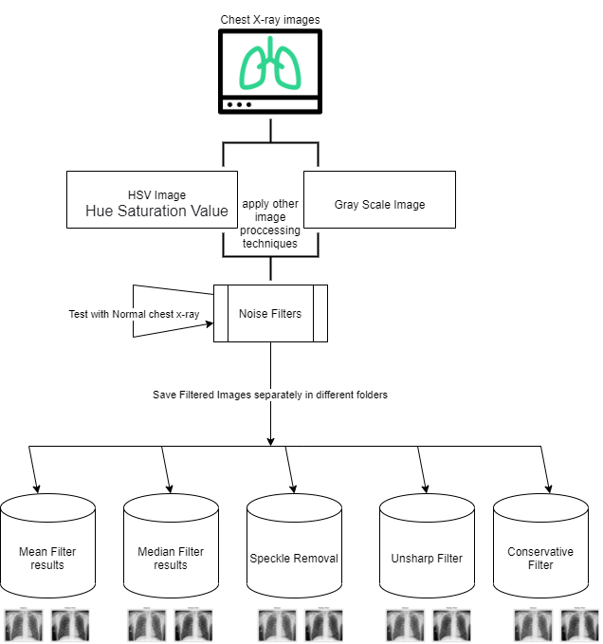After collecting the chest x-ray dataset I am going to build a model to convert the given images to HSV and Gray scale images by using OpenCV library. With the help of same library I will apply the different types of noise detecting and removing algorithms such that it will remove different type of noisy data on the image. In the next step I will store all the output images to

Figure 2: Noise filtering process on chest X-ray images

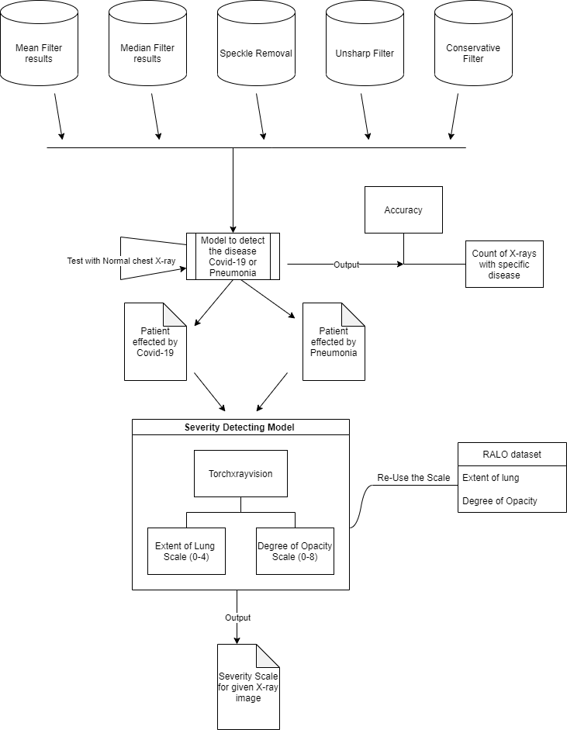different folders based on the filter name as shown in the figure 2 so, that it will helpful while applying the detecting algorithm and severity model. The main advantage of doing this is to test the same image by removing different noisy data on it if we do so I hope I will get good results with more accuracy. In the same way, we will take sample of testing images to test the model on both diseases. In the Second phase of my research, I will develop a model to detect the disease affected to the human based on the chest x-ray it may be Covid-19 or Pneumonia. This model will give Total accuracy for given dataset and the table which specifies number of the x-rays those are effected by specific disease.

Figure 3: Detecting the severity of the diseased chest X-ray image

In the next step as shown in figure 3, severity can be calculated by using RALO dataset given by the radiologists [13]. This severity model will take specific disease chest x-ray as an input and will give severity scale in the form extent of lung and degree of opacity. As per know, my idea is to develop the severity model to take only one input image to detect the severity of the disease.

# **Implications and contributions to knowledge**

As per my theoretical research, total world is fighting with COVID-19 from past two years. But detecting this disease inside lungs will cost the human more time and money. If I develop the Auto ML pipeline in future it will be helpful any person, he can do his own analysis on the chest X-ray to identify the COVID-19 and pneumonia inside the effected lungs as well as severity scale will help to identify the infection of the disease inside the lungs. I hope it will be help radiologists and clinicians to achieve a faster and understandable diagnosis using the full potential of Machine Learning, without the prerequisite of having to code in any programming language.

In this future, I will do analysis on auto ML technique and how it will help to my research by taking single input from the user. More testing I will do on this Auto ML model to understand how changing number of training images or using testing images affects the performance of the Auto ML pipeline Model when compare to the other models.

# **References**

*[1] World Health Organization (2020) Naming the coronavirus disease (covid-19) and the virus that causes it. https://www.who.int/emergencies/diseases/novel-coronavirus-2019/technical-guidance/naming-the-coronavirus-disease-(covid-2019)-and-the-virus-that-causes-it*

*[2] World Health Organization (2020) The continuing 2019-ncov epidemic threat of novel coronaviruses to global health - the latest 2019 novel coronavirus outbreak in wuhan, China. https://pubmed.ncbi.nlm.nih.gov/31953166/*

*[3] S. Schulte, M. Nachtegael, V. De Witte, D. Van der Waken and E. E. Kerre, “A fuzzy impulse noise detection and reduction method,” IEEE Trans. Image Process., vol. 15, no. 5, pp. 1153-1162, May 2006*

*[4] Deep representation learning of electronic health records to unlock patient stratification at scale by Isotta Landi*

*[5] Jones, Jeremy. “Chest X-Ray Review: ABCDE: Radiology Reference Article.” Radiopaedia Blog RSS. Accessed December 6, 2021. https://radiopaedia.org/articles/chest-x-ray-review-abcde.*

*[6] W. Luo, “Efficient removal of impulse noise from digital images,” IEEE Trans. Consumer Electron., vol. 52, no. 2, pp. 523-527, May 2006.*

*[7] S.W Chiu, J.H Wang, K.H Chang, T.H Chang, C.M Wang, C.L Chang, C.T. Tang, C.F. Chen, C.H.Shih, H.W. Kuo and L.C. Wang, 2014. A fully integrated nose-on-a-chip for rapid diagnosis of ventilator- associated pneumonia. IEEE transactions on biomedical circuits and systems, 8(6), pp.765-778.*

*[8] S. Zhang and M.A. Karim, “A new impulse detector for switching median filter,” IEEE Signal Process. Lett., vol. 9, no. 11, pp. 360-363,Nov. 2002*

*[9] Kenny Kal Vin Toh, Student Member, IEEE, Haidi Ibrahim, Member, IEEE, and Muhammad Nasiruddin Mahyuddin, Member, IEEE “Salt-and-Pepper Noise Detection and Reduction Using Fuzzy Switching Median Filter”*

*[10] J. S. Lee,L. Jurkevich,P. Dewaele,P. Wambacq &A. Oosterlinck “Speckle filtering of synthetic aperture radar images” Published online: 19 Oct 2009*

*[11]. ” A. Wong, Z. Q. Lin, L. Wang, A. G. Chung, B. Shen, A. Abbasi, M. Hoshmand-Kochi & T. Q. Duong “Towards computer-aided severity assessment via deep neural networks for geographic and opacity extent scoring of SARS-CoV-2 chest X-rays*

*[12]. Alexander Wong, Zhong Qiu Lin, Linda Wang, Audrey G. Chung, Beiyi Shen, Almas Abbasi, Mahsa Hoshmand-Kochi, Timothy Q. Duong “Towards computer-aided severity assessment via training and validation of deep neural networks for geographic extent and opacity extent scoring of chest X-rays for SARS-CoV-2 lung disease severity”*

*[13]. Joseph Paul Cohen Stanford University; Beiyi Shen; Almas Abbasi; Mahsa Hoshmand-Kochi; Samantha Glass; Haifang Li; Matthew P Lungren; Akshay Chaudhari; Tim Q Duong ” Stonybrook Radiographic Assessment of Lung Opacity (RALO) dataset is here: Pneumonia severity scores for 2373 images”* [*https://zenodo.org/record/4634000#.YX2YGp7MJPY*](https://zenodo.org/record/4634000#.YX2YGp7MJPY)

*[14]. Shivani Guptaa, Atul Guptab Dealing with Noise Problem in Machine Learning Data-sets: A Systematic Review*

*[15] Semi-Supervised Learning of the Electronic Health Record for Phenotype Stratification Brett K. Beaulieu-Jones*

*[16] Arjun Sarkar, Joerg Vandenhirtz, Jozsef Nagy, David Bacsa, Mitchell Riley Identification of Images of COVID‑19 from Chest X‑rays Using Deep Learning IEEE trans*

*[17] Amit KumarJaiswal PrayagTiwari SachinKumar DeepakGupta AshishKhanna Joel J.P.C.Rodrigues Identifying pneumonia in chest X-rays: A deep learning approach*

*[18] Nilanjan Dey , Yu-Dong Zhang , V. Rajinikanth, R. Pugalenthi , N. Sri Madhava Raja “Customized VGG19 Architecture for Pneumonia Detection in Chest X-Rays” IEEE Trans*

*[19] Varela-Santos, Sergio, and Patricia Melin. “A New Approach for Classifying Coronavirus COVID-19 Based on Its Manifestation on Chest x-Rays Using Texture Features and Neural Networks.” Information Sciences 545 (2021): 403–14. https://doi.org/10.1016/j.ins.2020.09.041.*

*[20] Waring, Jonathan, Charlotta Lindvall, and Renato Umeton. “Automated Machine Learning: Review of the State-of-the-Art and Opportunities for Healthcare.” Artificial Intelligence in Medicine 104 (2020): 101822. https://doi.org/10.1016/j.artmed.2020.101822.*

*[21] ieee8023. “IEEE8023/Covid-Chestxray-Dataset: We Are Building an Open Database of COVID-19 Cases with Chest X-Ray or CT Images.” GitHub. Accessed December 6, 2021. https://github.com/ieee8023/covid-chestxray-dataset.*

*[22] James C. Church, Yixin Chen, and Stephen V. Rice Department of Computer and Information Science, University of Mississippi, “A Spatial Median Filter for Noise Removal in Digital Images”, IEEE, page(s): 618- 623, 2008.*

*[23] Paul M (2020) Kaggle chest X-ray images (pneumonia) dataset. https://www.kaggle.com/paultimothymooney/chest-xray-pneumonia/*

*[24] Detecting Pneumonia in Chest X-Rays with Supervised Learning by Benjamin Antin, Joshua Kravitz, and Emil Martayan*

*[25] ieee8023. “IEEE8023/Covid-Chestxray-Dataset: We Are Building an Open Database of COVID-19 Cases with Chest X-Ray or CT Images.” GitHub. Accessed December 6, 2021. https://github.com/ieee8023/covid-chestxray-dataset/.*

*[26] “Coronavirus Disease (Covid-19) Situation Reports.” World Health Organization. World Health Organization. Accessed December 6, 2021. https://www.who.int/emergencies/diseases/novel-coronavirus-2019/situation-reports.*

*[27] Borghesi, A., Maroldi, R., 2020. COVID-19 outbreak in italy: experimental chest x-ray scoring system for quantifying and monitoring disease progression. La radiologia medica .*

*[28]* [*Stephanie A. Walker*](https://www.ncbi.nlm.nih.gov/pubmed/?term=Walker%20SA%5BAuthor%5D&cauthor=true&cauthor_uid=32815519)*,*[*Sheng Xu*](https://www.ncbi.nlm.nih.gov/pubmed/?term=Xu%20S%5BAuthor%5D&cauthor=true&cauthor_uid=32815519)*,*[*Thomas H. Sanford*](https://www.ncbi.nlm.nih.gov/pubmed/?term=Sanford%20TH%5BAuthor%5D&cauthor=true&cauthor_uid=32815519)*,*[*Evrim B. Turkbey*](https://www.ncbi.nlm.nih.gov/pubmed/?term=Turkbey%20EB%5BAuthor%5D&cauthor=true&cauthor_uid=32815519)*,*[*Stephanie Harmon*](https://www.ncbi.nlm.nih.gov/pubmed/?term=Harmon%20S%5BAuthor%5D&cauthor=true&cauthor_uid=32815519)*,*[*Baris Turkbey*](https://www.ncbi.nlm.nih.gov/pubmed/?term=Turkbey%20B%5BAuthor%5D&cauthor=true&cauthor_uid=32815519)*, and*[*Bradford J. Wood*](https://www.ncbi.nlm.nih.gov/pubmed/?term=Wood%20BJ%5BAuthor%5D&cauthor=true&cauthor_uid=32815519) *Stephanie A. Walker, Sheng Xu, Thomas H. Sanford, Evrim B. Turkbey, Stephanie Harmon, Baris Turkbey, and Bradford J. Wood “Determination of disease severity in COVID-19 patients using deep learning in chest X-ray images”*

*[29] Infection severity detection of CoVID19 from X-Rays and CT scans using artificial intelligence NCD Adhikari - International Journal of Computer (IJC), 2020 - core.ac.uk*

*[30] Fang, Yicheng, Author AffiliationsFrom the Department of Radiology, Chen N, Et Al., Chung M, Xie X, Song F, et al. “Sensitivity of Chest CT for Covid-19: Comparison to RT-PCR.” Radiology, February 19, 2020. https://pubs.rsna.org/doi/10.1148/radiol.2020200432.*

*[31] T. H. Pingale and H. T. Patil, Analysis of Cough Sound for Pneumonia Detection Using Wavelet Transform and Statistical Parameters,2017 International Conference on Computing, Communication,Control and Automation (ICCUBEA), Pune, 2017, pp. 1-6.*

*[32] Cohen, J.P., Dao, L., Morrison, P., Roth, K., Bengio, Y., Shen, B., Abbasi, A., Hoshmand-Kochi, M., Ghassemi, M., Li, H., Duong, T.Q., 2020a. Predicting COVID-19 pneumonia severity on chest x-ray with deep learning.arXiv:2005.11856*

*[33] U.R Abeyratne, V Swarnkar, R Triasih, and A Setyati, 2013, July. Cough Sound Analysis-A new tool for diagnosing Pneumonia. In 2013 35th Annual International Conference of the IEEE Engineering in Medicine and Biology Society (EMBC), pp. 5216-5219, IEEE.*

# **Research schedule**

|  |  |  |
| --- | --- | --- |
| **Research phase** | **Objectives** | **Deadline** |
| Divide the data set based on the area of selection | * Selecting the images for each disease  * Separating all images in different folders | 17-01-2022 |
| Research on similar exercise on selected data set | * Referring the different existing research papers to check the approach they went on detecting the disease and other model | 24-01-2022 |
| Selecting or finding the features in the dataset | **\*** try to find the labels, features of each image  * verify the features of RALO dataset for detecting the severity | 31-01-2022 |
| Building the AutoML model Architecture | * A design and construction of the AutoML model for my research | 07-02-2022 |
| Selecting and applying the ML model | * Applying the selected model for the sample dataset | 14-02-2022 |
| Building the pipeline model to run | * Merging the each selected model and try to build that model to run on its own. | 21-02-2022 |
| Testing and validating the AutoML model | * testing AutoML model by using our dataset.  * Apply training and testing dataset in separate. | 07-03-2022 |
| Solving and Validating the Research Questions | * check whether i resolved the research questions or not.  * if yes, validate the each question with dataset | 14-03-2022 |
| Writing the whole research paper Phase 1 |  | 21-03-2022 |
| Writing the whole research paper  Phase 2 |  | 22-03-2022 |
| Writing the whole research paper |  | 28-03-2022 |
| Presenting the paper |  | 04-04-2022 |